Comprehensive Metasploitable2 Exploitation Walkthrough

This walkthrough outlines the step-by-step process of exploiting different ports on Metasploitable2 for educational purposes.

Identifying the victim’s IP addr ess using the `ifconfig` command.

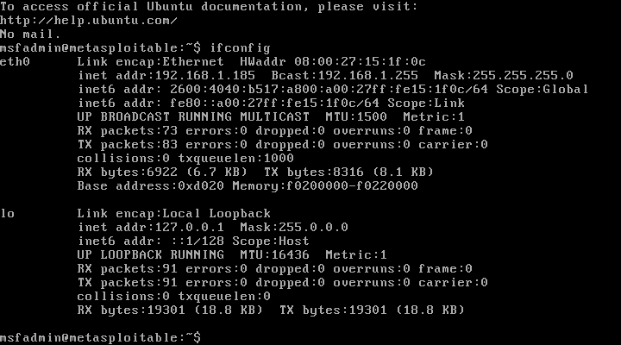
Utilizing Kali Linux with Nmap to scan open ports on the Metasploitable2 machine: ‘ommand: sudo nmap -sV -Pn Target/Victim Machine IP`.
Press enter or click to view image in full size


Method 1: Establishing a connection using FTP credentials.
Command: `ftp 192.168.1.185`
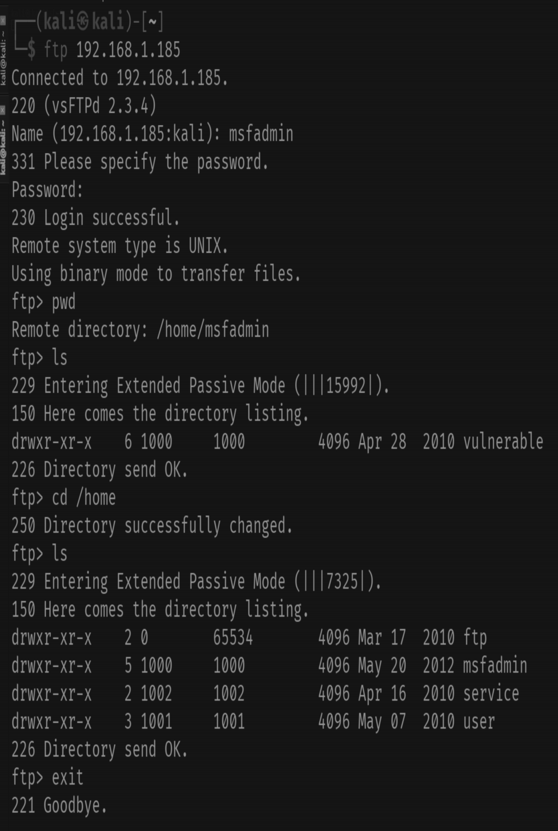
Method 2: Exploiting FTP through the Metasploit framework.

Commands: msfconsole
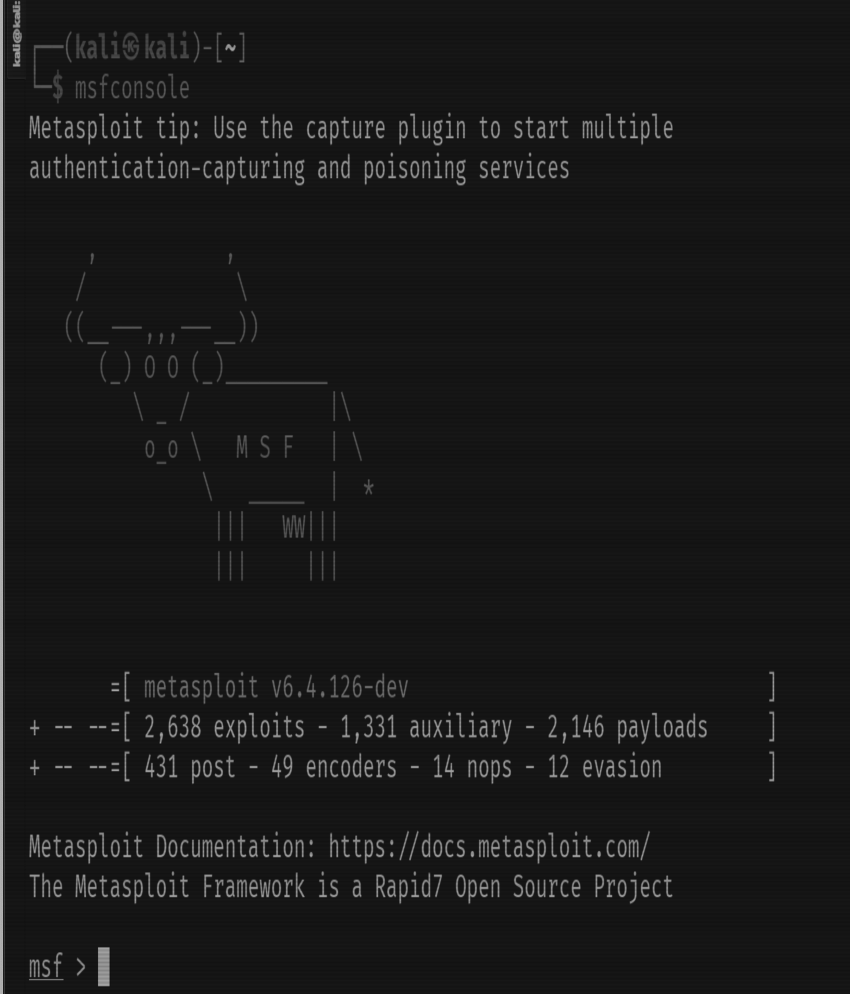
vsftpd (specifically search vsftpd within the Metasploit framework) is primarily done to identify and exploit a critical backdoor vulnerability in version 2.3.4. This version was briefly compromised in 2011, allowing attackers to gain root access to the machine.

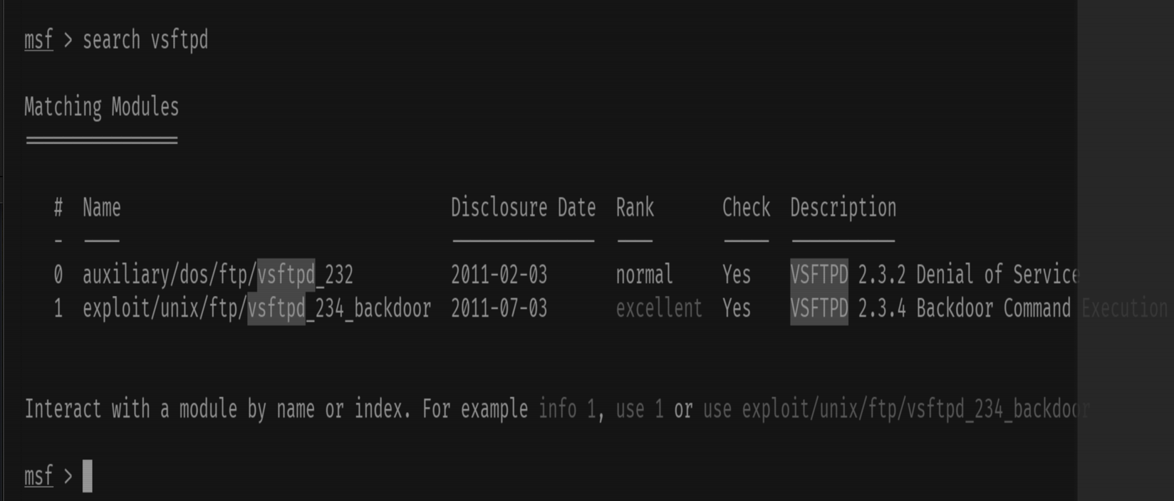

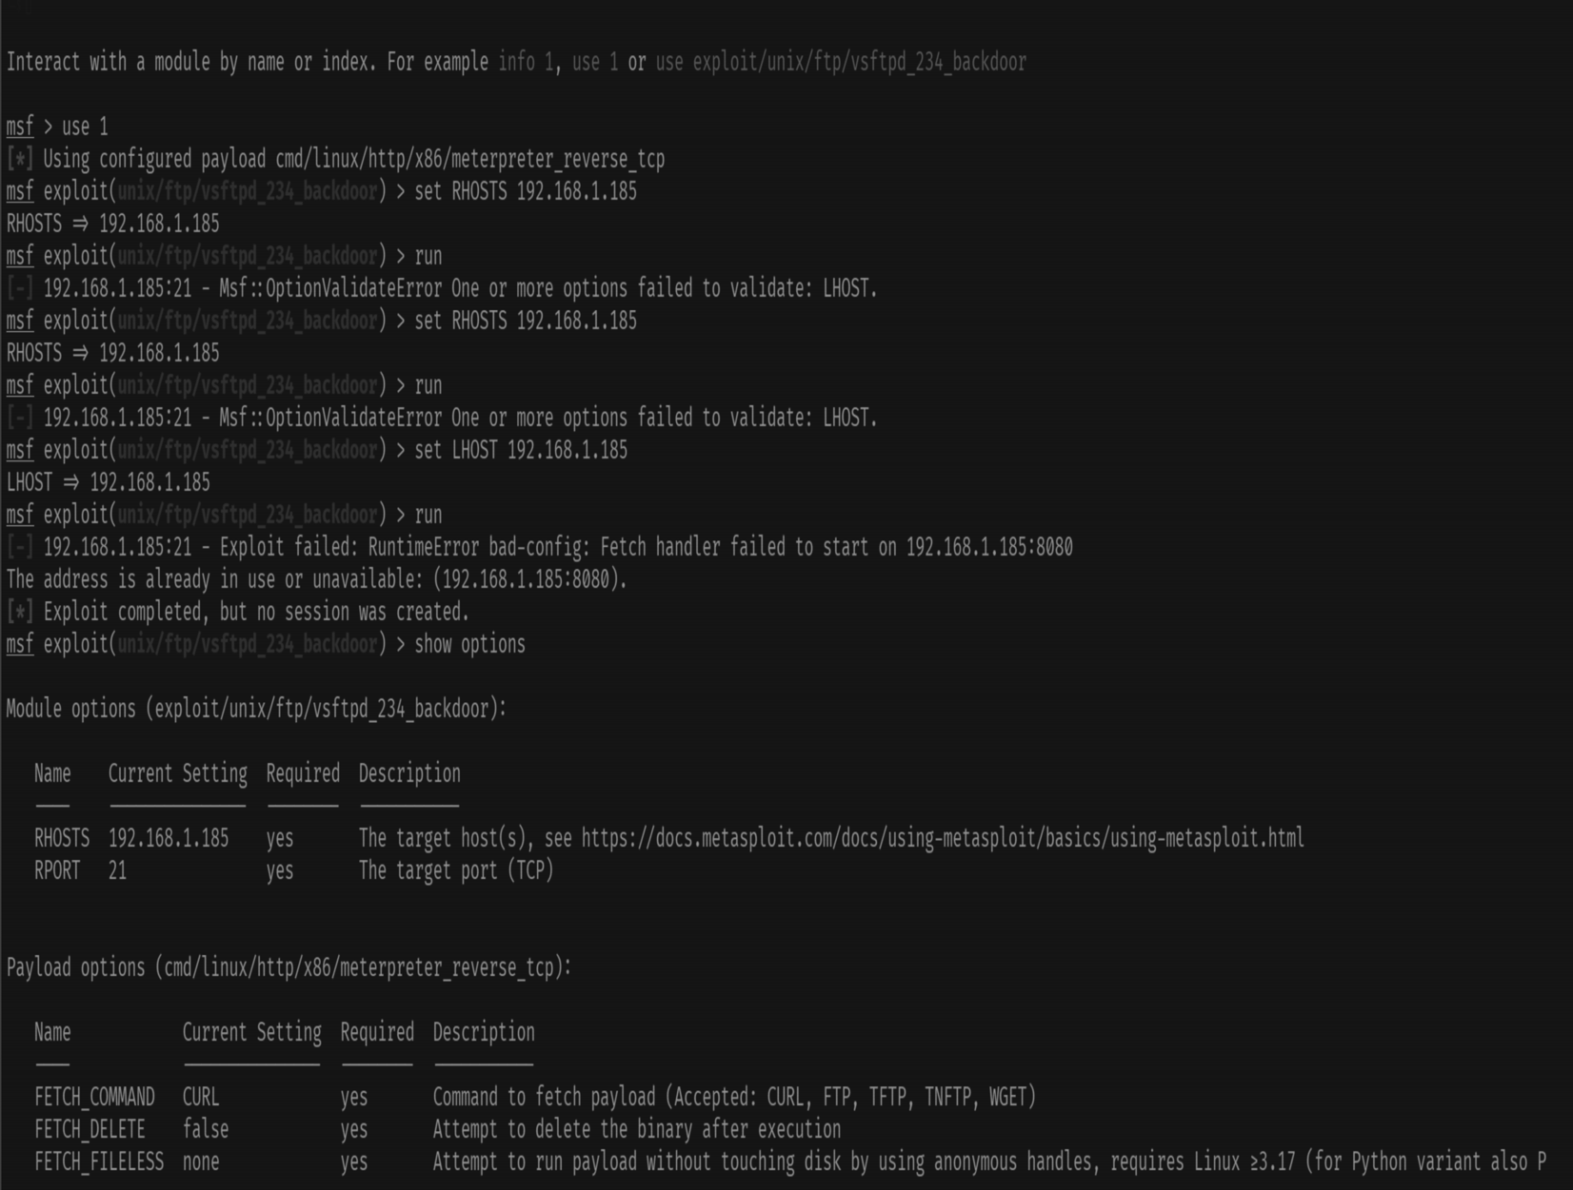

Telnet Exploitation (Port 23):
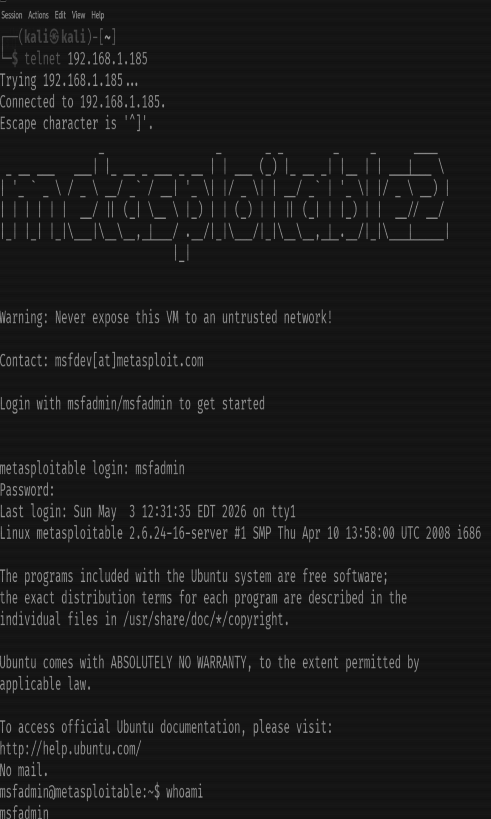

VNC Exploitation (Port 5900):
Port 5900 is commonly associated with VNC (Virtual Network Computing), a remote desktop sharing system. When used in combination with VNC, port 5900 is often the default port for the initial display (desktop) on a VNC server. VNC allows a user to view and interact with the graphical desktop environment of a remote computer over a network.
Utilizing Metasploit to exploit VNC login.- Commands: `msfconsole`
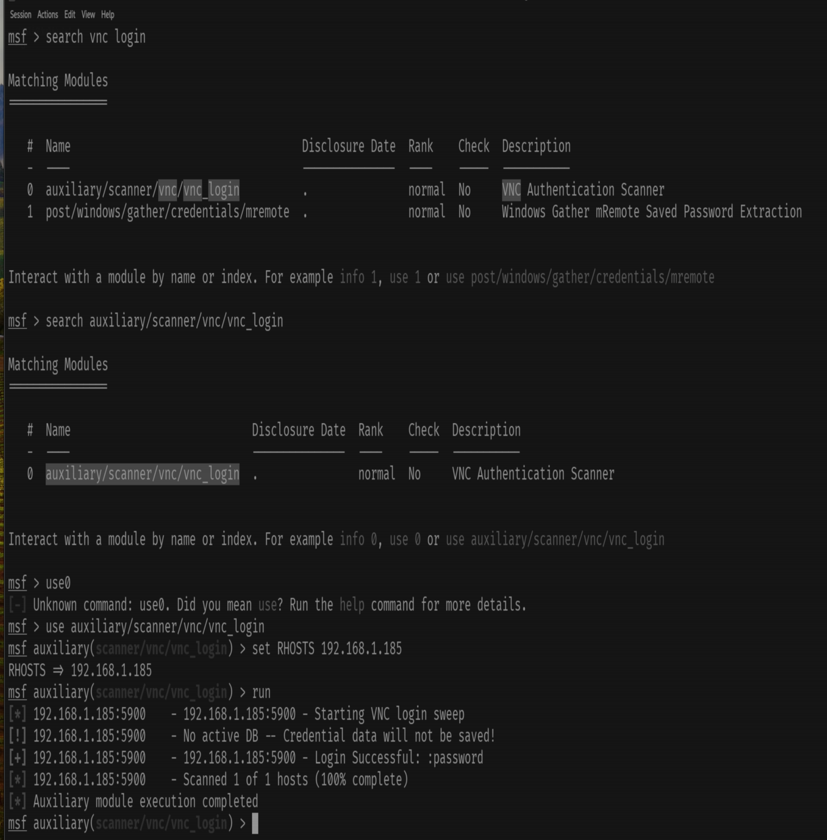
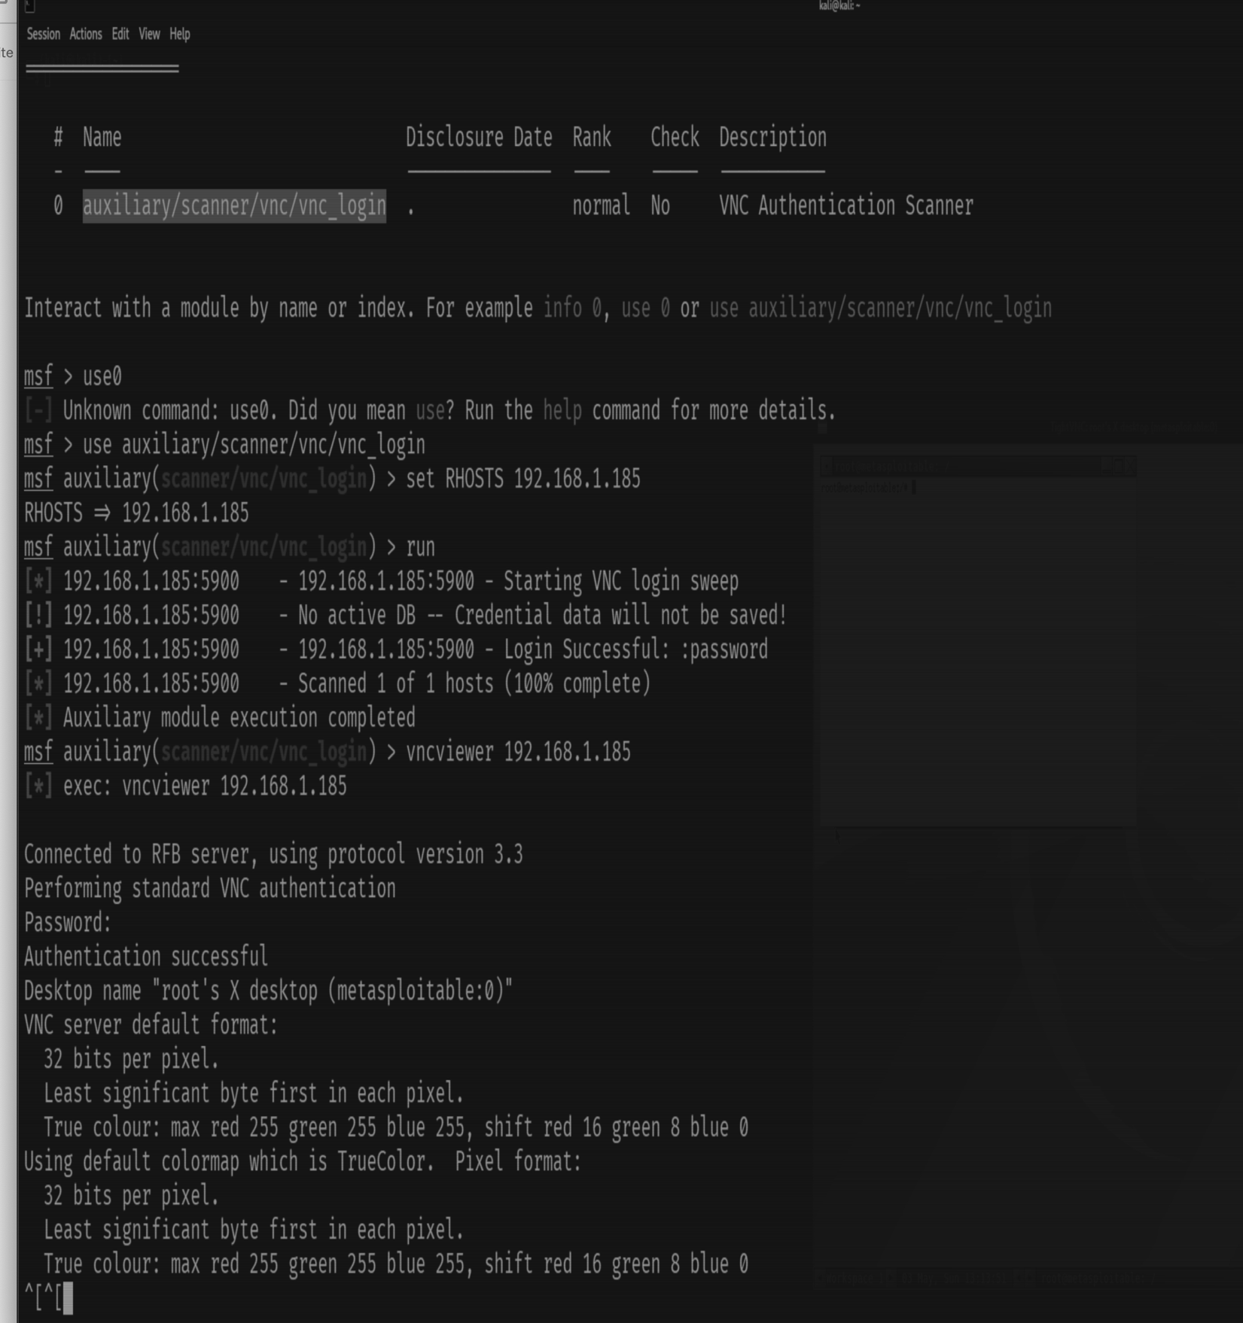
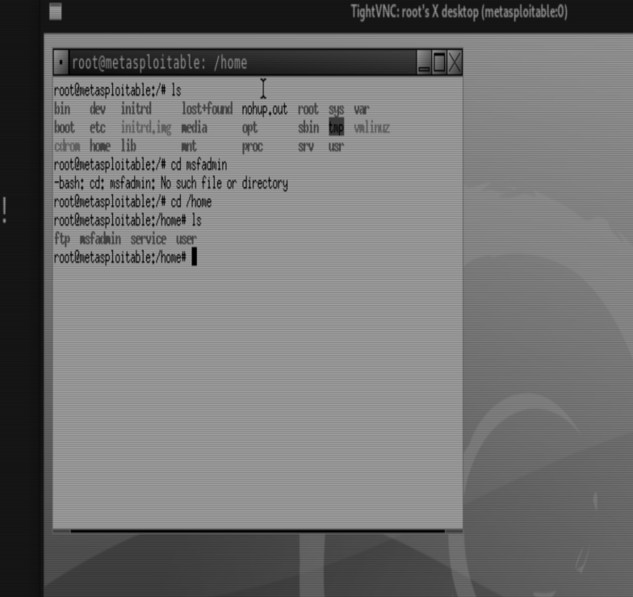

PostgreSQL Exploitation (Port 5432):
PostgreSQL is a powerful open-source relational database management system (RDBMS) known for its extensibility and advanced features, providing a robust platform for managing and querying structured data.
- Searching and exploiting PostgreSQL vulnerabilities.
- Commands:- `msfconsole`-`search PostgreSQL`
Press enter or click to view image in full size

